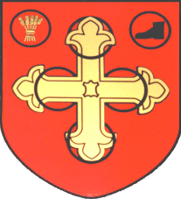
Clarification Notice June 2023

We have noticed that there are rumours circulating on social media and as it is our policy not to engage on individual posts, we thought it best to post an update here and clarify our position.
All tasks and events organised by the town council rely on 3 things: Safety, Legality and Timeliness.
As you may be aware our last town clerk, who also had the role of responsible financial officer, resigned earlier this year and we had to start the process of recruiting staff. During the time when we had no one in these posts certain legal restrictions are in force that meant we could not operate in the normal way. The council has now employed a team to run the office-based systems and have covered our “due diligence” by ensuring we split the role so we should not be left in a similar situation again.
Within this due diligence and insurance review, it was discovered that an annual lottery license would be required to run the duck race. Unfortunately, due to the time restraints, it was not possible to get all ‘our ducks in a row’ in order for the event to go ahead in the planned timeframe.
We realise this is a disappointment to many but please be assured that the planning was done, and we have everything ready to launch next years event on time and in full. Any existing ticket purchases are fully documented and will be transferred to next year’s tickets.
There will be a second post soon detailing all the events that will be going ahead and we look forward to seeing many of you at them.

For any further clarification please contact the Town Clerk

